

**NAME:** NASTIC NAOMI MASAYI

**COURSE CODE:** APT1030

**COURSE NAME:** FUNDAMENTALS OF PROGRAMMING LANGUAGES

**INSTRUCTOR NAME:** EDWARD OMBUI PhD

**PROGRAM:** APPLIED COMPUTER TECHNOLOGY

**DATE OF SUBMISSION:** MAY 24, 2024

**ASSIGNMENT:**

1) Build a knowledge base that includes facts and relationships about your family, extending to a minimum of four generations.

The rules should include who are: siblings (); father (); mother ();

2) Implement it as a Family Tree in Prolog.

3) The program should be able to answer queries such as: mother (X, Y); siblings (X, Y);

**PARENT_CHILD RELATIONSHIPS:**

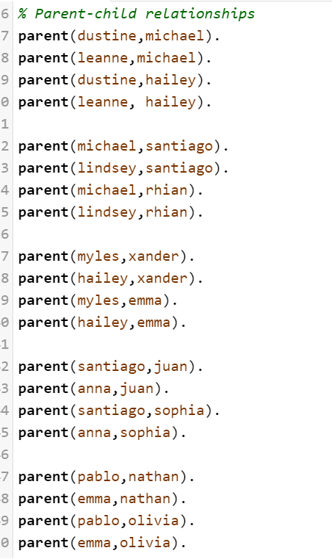

**FAMILY FACTS:**

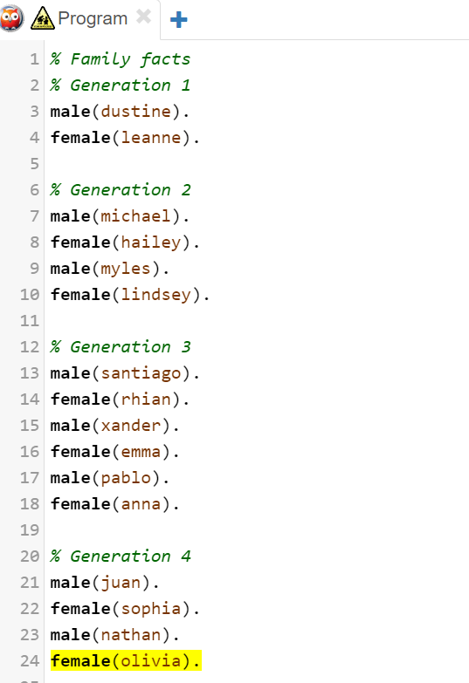

**RULES FOR RELATIONSHIPS:**

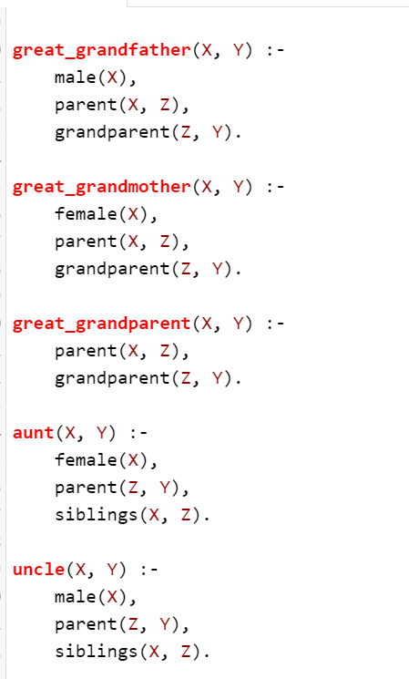

**RULES FOR RELATIONSHIPS:**

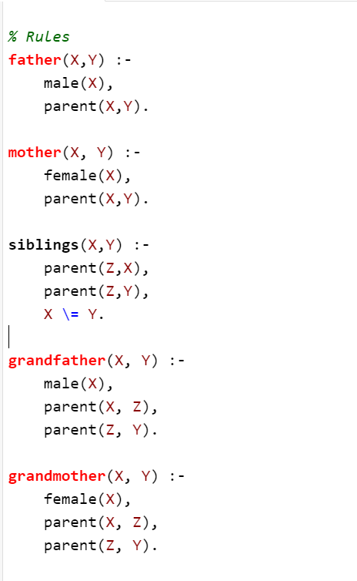

**RULES FOR RELATIONSHIPS:**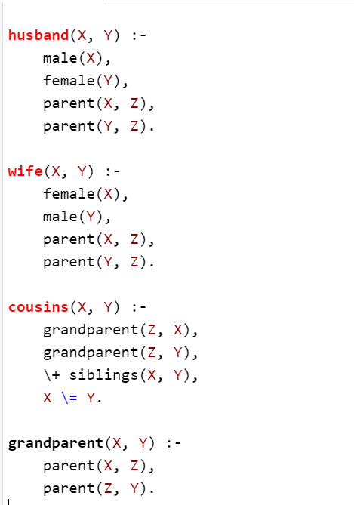

**SAMPLE QUERIES WITH THEIR OUTPUT:**

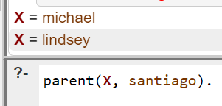

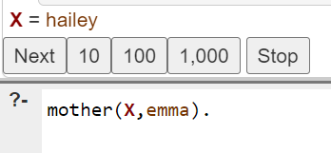

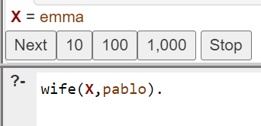

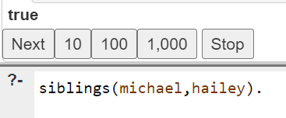

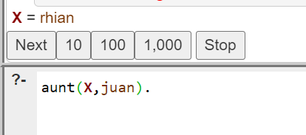

**SAMPLE QUERIES WITH THEIR OUTPUT:**

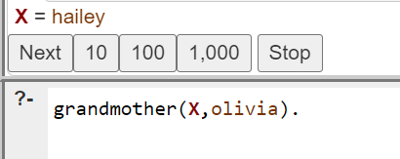

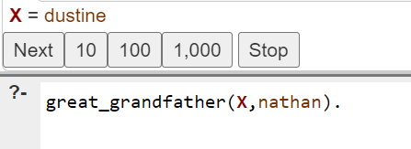

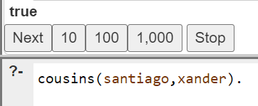

Query on whether Santiago ad Rhian are cousins when they are not to test the application:

